PCM Hackathon InterSystems IRIS for Health Setup Steps

Contents
mTLS Setup 2
TLS Configuration 2
JWT Introspection Authentication 3
X.509 Certificate Configuration 3
OAuth Client 4
Server Description 4
Client Configuration 5
FHIR Endpoint Authorization Settings 7
OAuth Client Name 7
Patient Identifier to Patient Resource ID Context Transformation (and Sensitive Tagging “Double” Verification) 8
FHIR Endpoint Interactions Strategy 8
Optional – Include IAM (InterSystems API Manager) 10
Define Service, Routes, and add Plugins as desired (e.g. OAuth-related, mTLS-related, ACL, Rate Limiting, Request Size Limiting) 10
Mock PCM Admin Side 12
Custom Source Definition 12

mTLS Setup
TLS Configuration (programmatically)
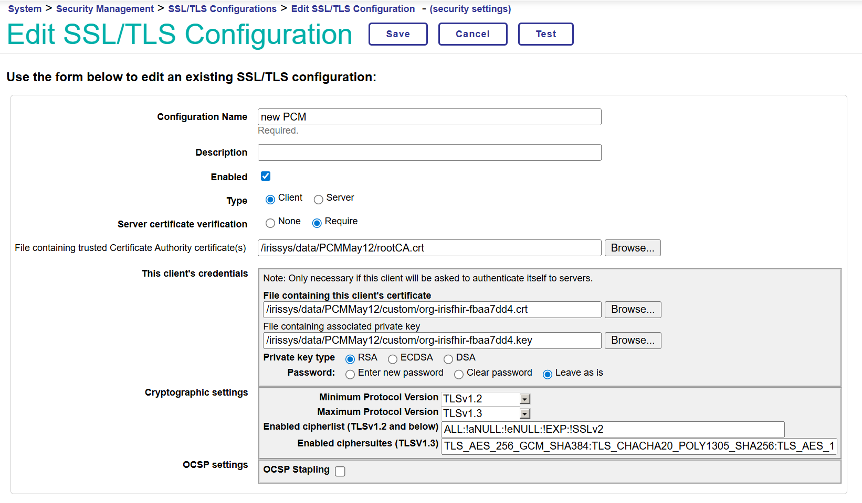

JWT Introspection Authentication
X.509 Certificate Configuration (programmatically)
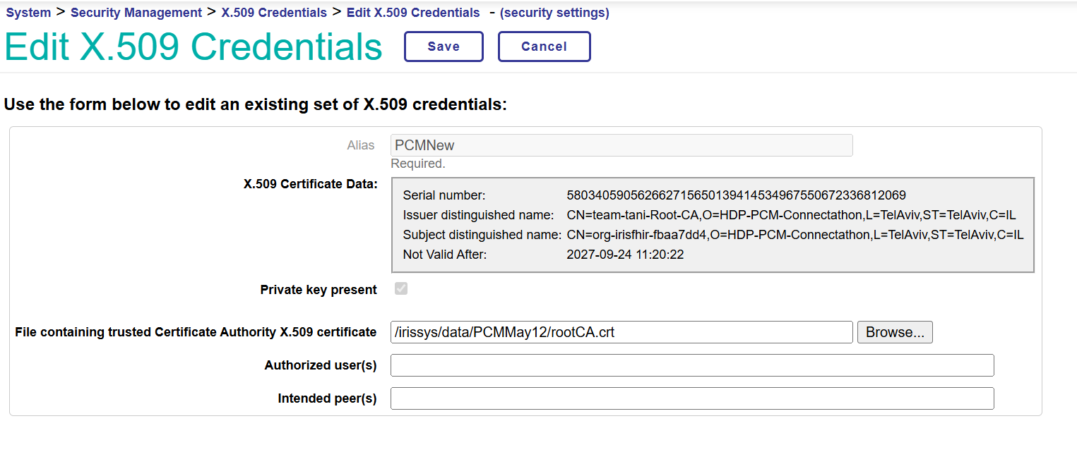

OAuth Client
Server Description (programmatically)
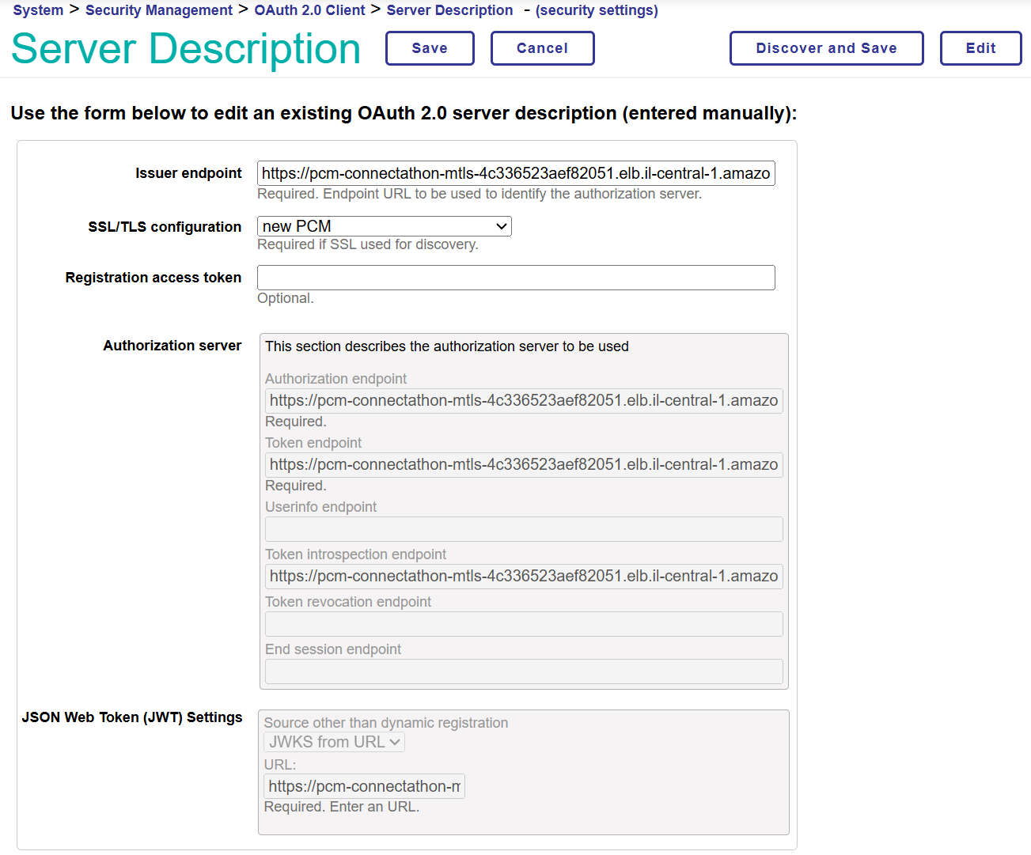
Client Configuration (programmatically)
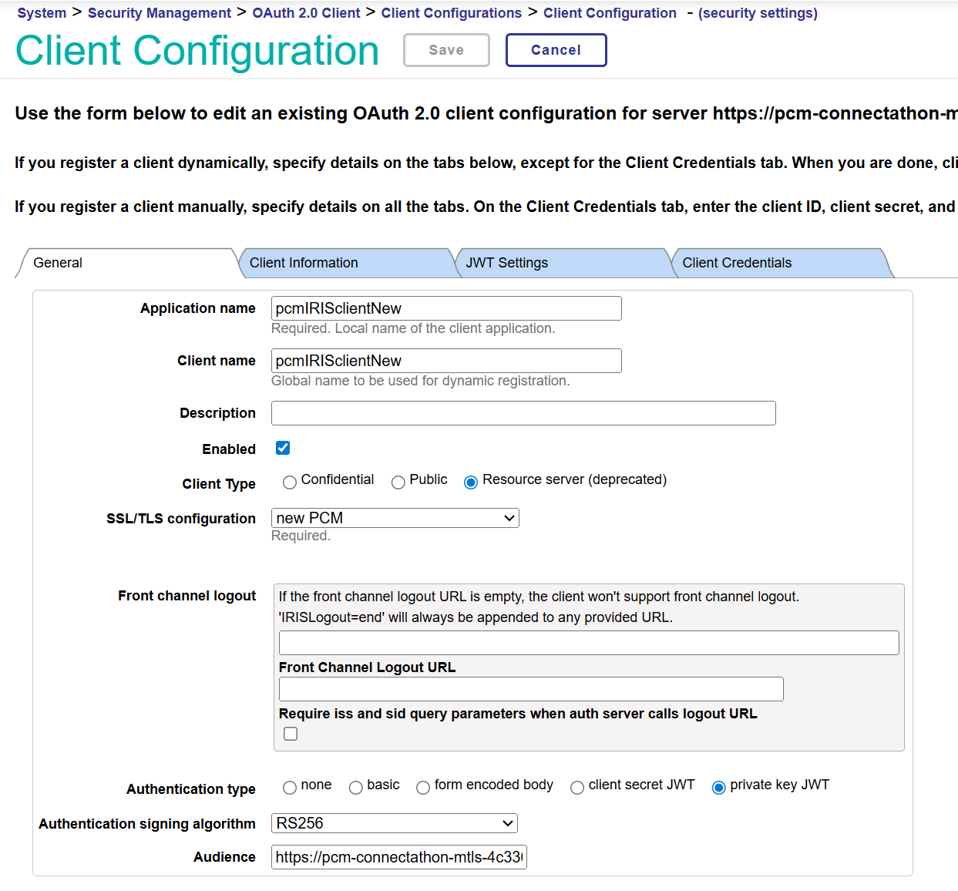

Client Configuration (cont.)
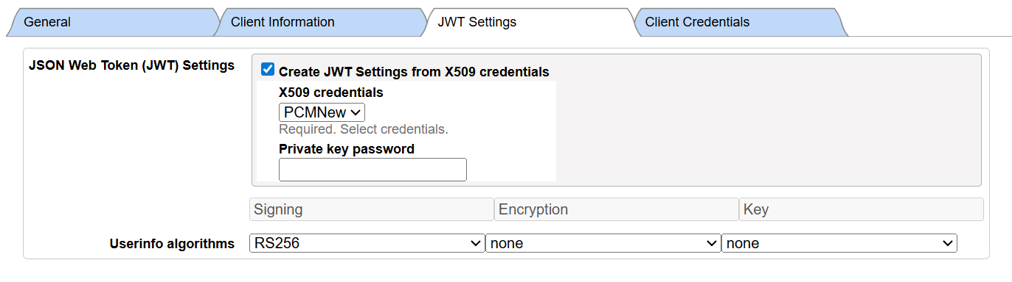
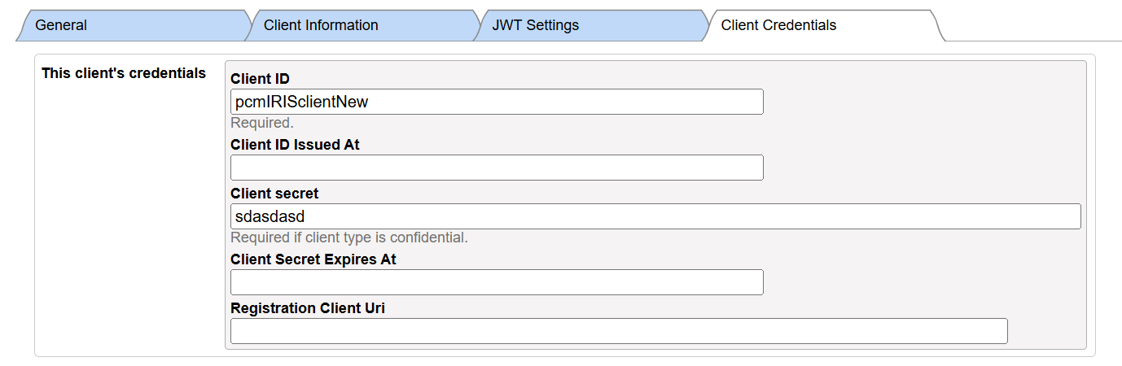

FHIR Endpoint Authorization Settings
OAuth Client Name (and add Audiences as needed, requires v2026.2; if older see this post) (programmatically)
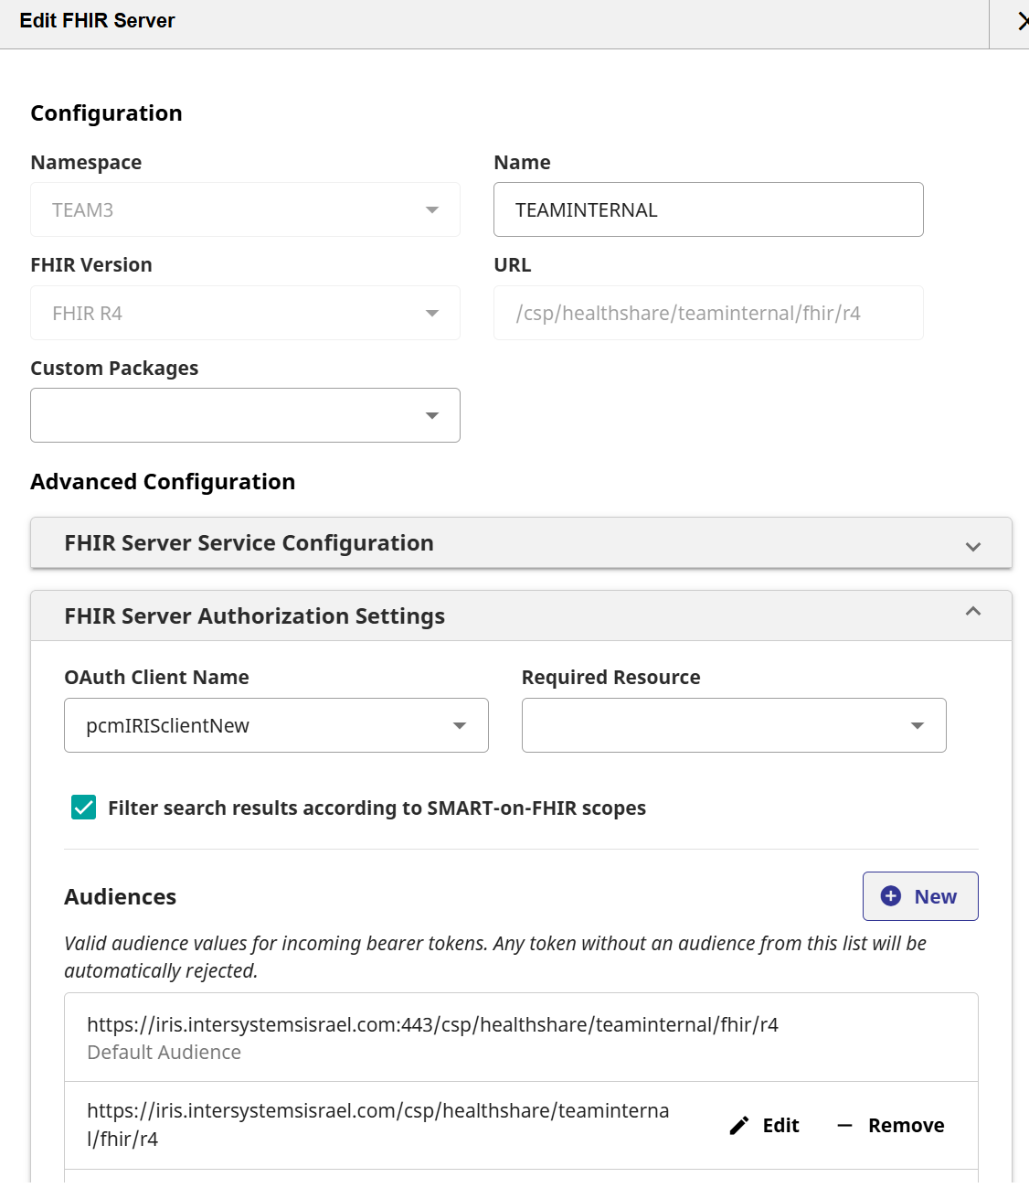

Patient Identifier to Patient Resource ID Context Transformation (and Sensitive Tagging “Double” Verification)

FHIR Endpoint Interactions Strategy
Subclass Base Classes (docs details)
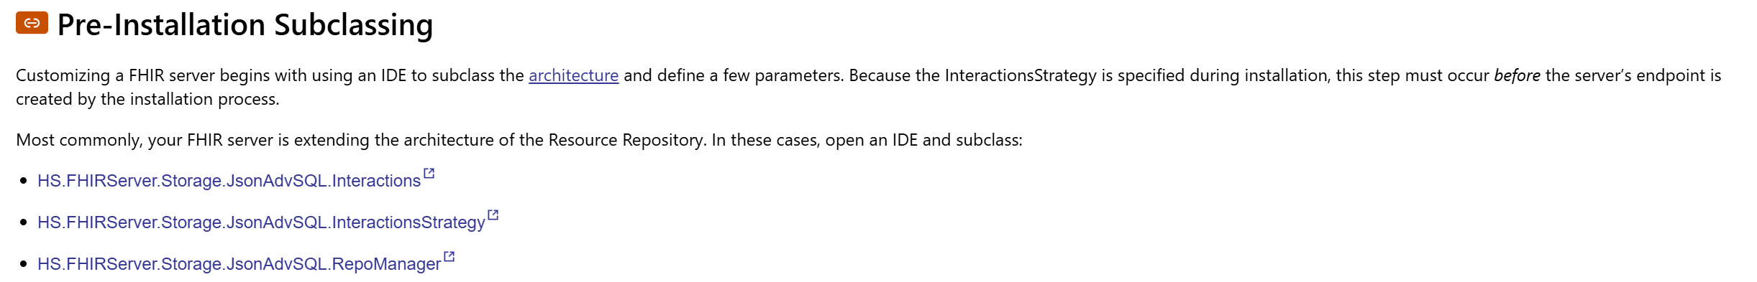
Override OAuth Token Handler Class Method (docs details, class reference, specific method)
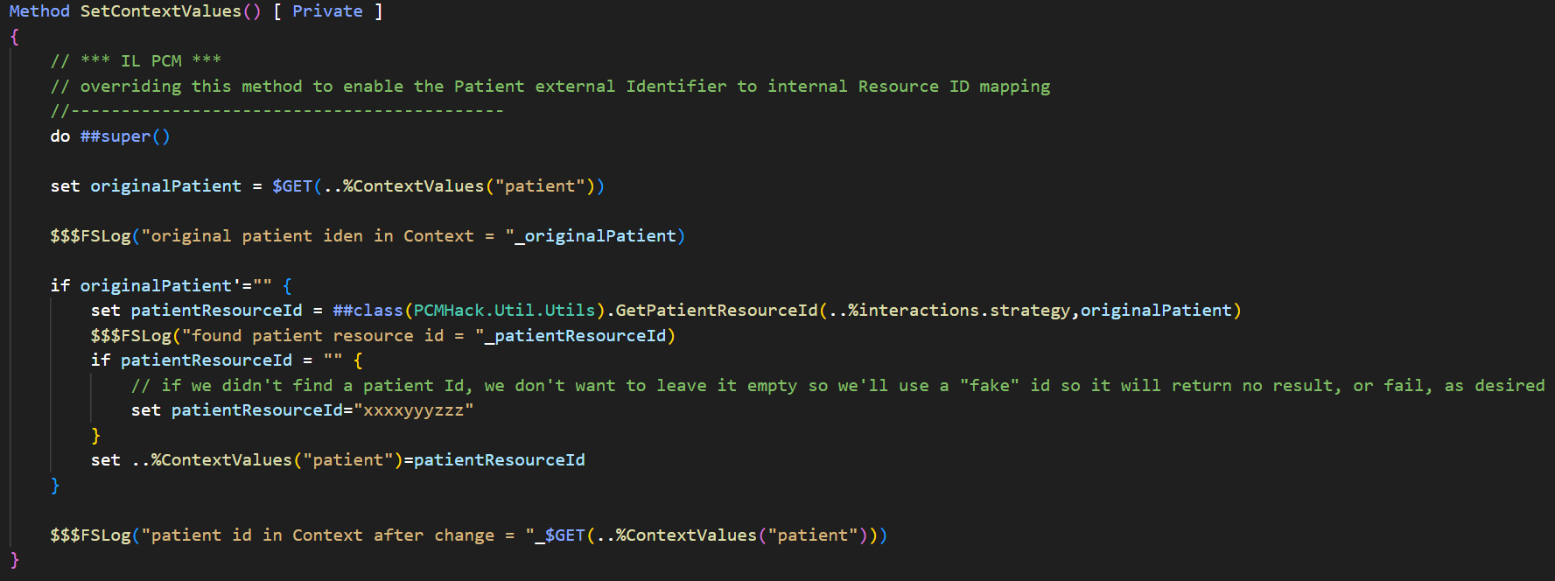

Patient Resource ID per Identifier Lookup Helper Method (related methods reference – Query Parameters Creation, Search)
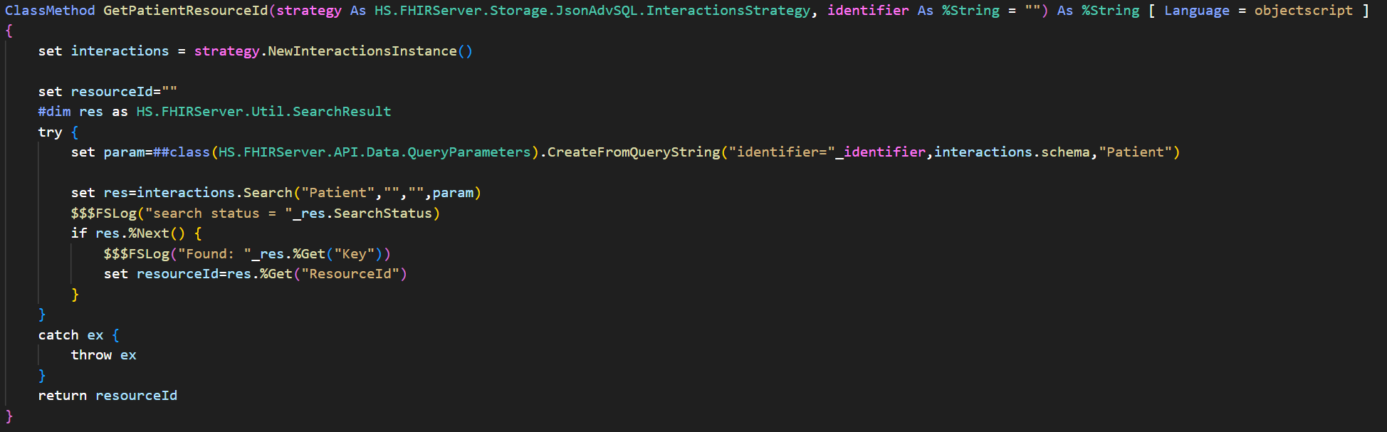

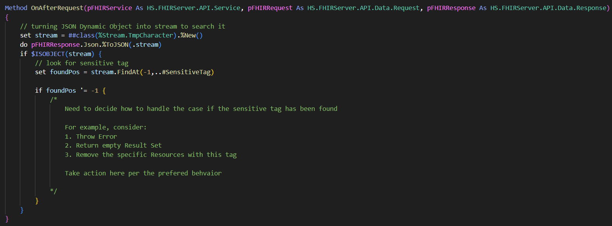
If desired, further check/validation can be performed, for example in a PostProcessSearch method customization (method reference), or for example in a OnAfterRequest method customization (method reference) for “double checking” if results includes any “sensitive tagged” data.
Here is some sample code:

Optional – Include IAM (InterSystems API Manager)

Define Service, Routes, and add Plugins as desired (e.g. OAuth-related, mTLS-related, ACL, Rate Limiting, Request Size Limiting)
For example (Route configuration):
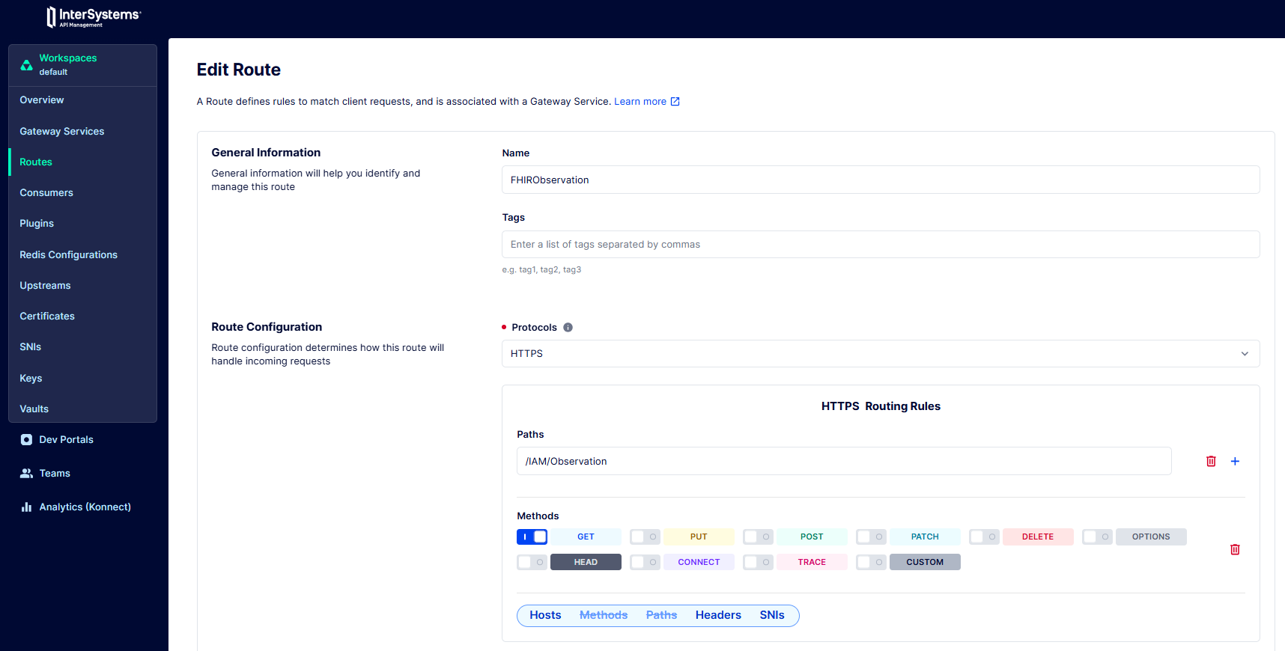
IAM cont. (sample Plugins)
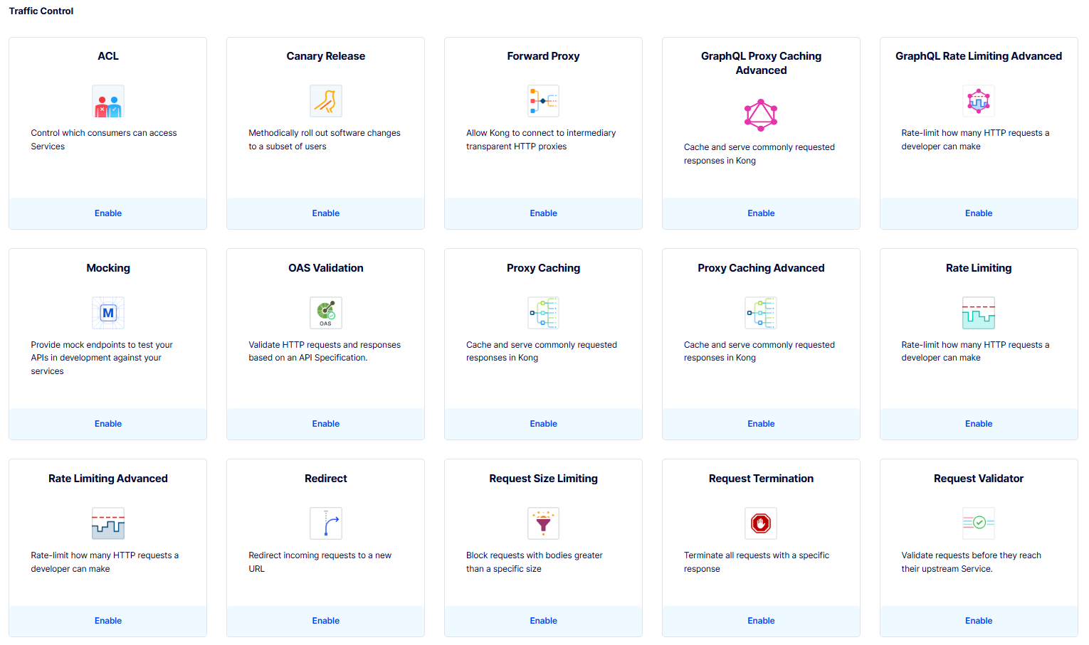
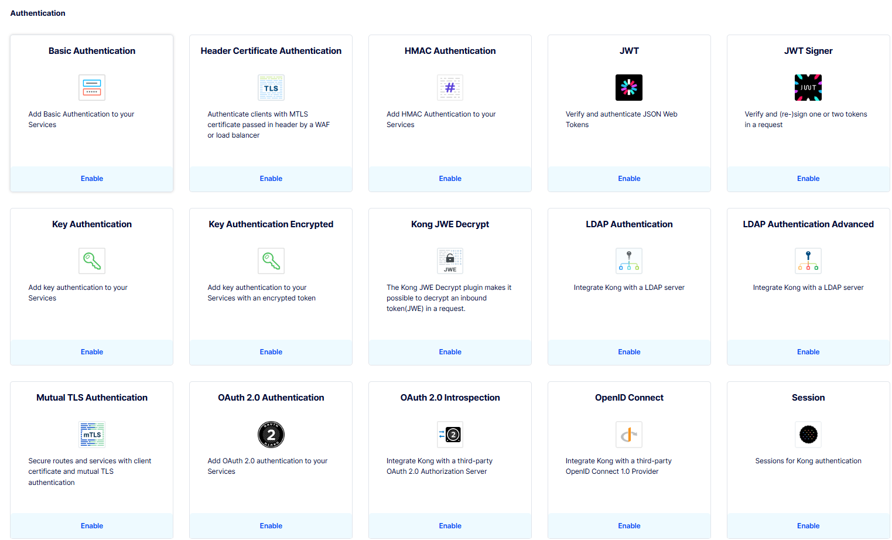

Mock PCM Admin Side

Custom Source Definition
(One with and one without the IAM)
